+ | Addition
- | Subtraction
* | Multiplication
/ | Division
% | Modulo (remainder) - Returns the integer remainder of dividing two operands.  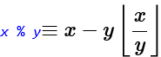
** | Exponentiation
= | Assigns value to a variable
& | AND
| | OR
~ | NOT
^ | XOR (or “power”)
<< | Left shift
>> | Right shift
== | Equal to
!= | Not equal
> | Greater than
> | Less than
>= | Greater than or equal to
<= | Less than or equal to
&& | And
|| | Or
! | Not
? : | Conditional operator  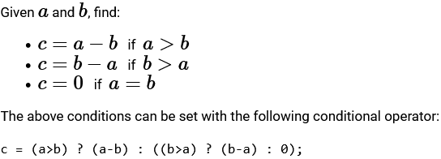

Grading variables (to be used in grading criterion + grading criteria):
_0, _1, _2, … | Student response for each answer  - First answer is numbered 0  - Can be referred to as {_0} in the sub-question text box
_a | List of the model answer, defined in the answer field
_r | List of the student’s response, which is the same size as _a
_d | List of the difference between elements  $_d = diff(_a, _r)$
_err | Absolute error
_relerr | Relative error

