**Moodle Formulas Quest Type Workshop**

The Moodle Formulas question type is a relatively new addition to the suite of question types available in Moodle Quiz. The question type is very powerful and is a significant upgrade to the existing Calculated question type. Its potential is quite large and enables us to:

* Make questions with large numbers of random variables so each student gets a unique data set
* Ask students questions that require algebraic answers
* Ask multistep questions that build on each other/use the same variables (we can also give students partial marks if they enter an incorrect solution into part a but then use that number to find the relatively correct answer to part b)
* Give partial marks for things such as the number of significant figures, units etc.
* Answer fields can be placed anywhere in the question so that we can create questions involving various answer structures such as coordinate, polynomial and matrix.

These functionalities can simplify the creation of questions in many fields related to mathematics, numbers, and units, such as physics, health sciences, business, and engineering.

This document contains four questions for you to try, these are ordered from easiest to hardest and incorporate a wide variety of the functionality of the Formulas question type.

If you do not have a course site to work with/don’t want to use your own, then feel free to use the ‘Moodle Formulas Workshop’ section of our course template site - <https://uo.unisa.edu.au/course/view.php?id=911>

**Question 1 – basic variables**

This question introduces some basic number and text variables for formulas questions. This question was adapted from [Dr Cormac Quigley](https://www.youtube.com/channel/UCuznGouzHQCN5dhux-uUH-g) who has some really good YouTube videos about Moodle formulas. Your finished question should look something like this:

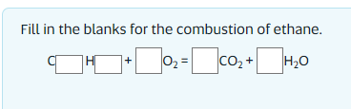

1. To add a Formulas question, go to the left-hand navigation and select *administration -> course administration -> question bank*. Then select *create a new question* and then *Formulas*.
2. Give your question a name (perhaps use your initials in the title to make it easier to find this question again should you need to edit it).
3. In the *random variables* box, you will enter a letter or word which you will then associate with a range of values, for this question, enter:  
    c={1:11:1};

to deconstruct the first line, it is assigning the letter c to be a random number between 1-11 (but not including 11), then it states that the random number should be generated with an interval of 1 (i.e. 1,2,3 etc.).

1. In the *global variables* box, you will enter any formulas that Moodle should use to manipulate the random variables you entered in the previous box, for this question, enter:  
    h = (2*c+2);

o = c+(h/4);

a = c;

b = h/2;

n = pick(c-1,"meth","eth","prop","but","pent","hex","hept","oct","non","dec");

the first line of this formula is telling Moodle to multiply variable c by two, add two and assign it to a new variable by the name h. The final line is telling Moodle to pick one of the words from the list based on the value of variable c.

1. In the *question text box* enter the following to display the variables and their values to students.  
    Fill in the blanks for the combustion of {n}ane.

{#1}

this is the question text the student will see, it contains the name of the chemical where {n} will be replaced by the text selected from the global variables. {#1} is a placeholder for the answer which we will look at in a moment.

1. Under *Part 1* go to the *answer* box and enter:  
    [c,h,o,a,b]  
   this tells Moodle what values to expect in what order in the students answer
2. In the *placeholder* box, enter:  
    #1

this tells Moodle the expected answers for each part of the question (as defined in the global variables box earlier)

1. In the *part’s text*  box enter:

C{_0} H{_1} + {_2}O2 = {_3}CO2 + {_4}H2O

this is the text that will be shown to students with spaces for the answers, the {_0} is the first answer, and is assigned the first value in the answer box (step 6).

1. Save your question and then preview and try it out.

**Question 2 – rounding, errors, and units**

Using rounding, tolerance errors and units are the next most common features used in Moodle Formulas question types.

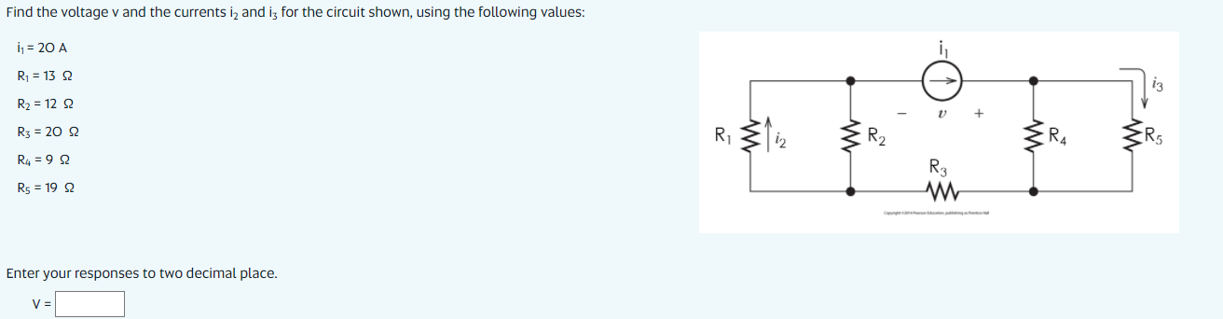

1. To add a Formulas question, go to the left-hand navigation and select *administration -> course administration -> question bank*. Then select *create a new question* and then *Formulas*.
2. Give your question a name (perhaps use your initials in the title to make it easier to find this question again should you need to edit it).
3. In the *random variables* box, you will enter a letter or word which you will then associate with a range of values, for this question, enter:  
    i1 = {1:21:1};

R1 = {1:21:1};

R2 = {1:21:1};

R3 = {1:21:1};

R4 = {1:21:1};

R5 = {1:21:1};

1. In the *global variables* box, you will enter any formulas that Moodle should use to manipulate the random variables you entered in the previous box, for this question, enter:  
    V = i1 * ((R1 * R2)/(R1 + R2) + R3 + (R4 * R5) / (R4 + R5));
2. In the *question text box* enter the following to display the variables and their values to students.  
    Find the voltage v for the circuit shown, using the following values:

i1 = {i1} A

R1 = {R1} Ω

R2 = {R2} Ω

R3 = {R3} Ω

R4 = {R4} Ω

R5 = {R5} Ω

Enter your responses to two decimal place. {#1}

1. Under *Part 1* click *show more* and in the *grading variables* box enter:  
    round1 = _0 == round(V,1);

round2 = _0 == round(V,2);

round3 = _0 == round(V,3);

errormin = _relerr < 0.01;

errormax = _relerr < 0.1;  
the first line tells Moodle to assign a value of 1 or 0 to the variable round1 depending on whether the students’ first answer is equal to the correct answer (V) and rounded to 0 decimal places (note: sig fig can be used instead of rounding if preferred). The last two lines check whether the students’ response is within the correct error range, either 0.01 or 0.1 depending on the tolerance.

1. In the *answer* box, enter:  
    round(V,2)

this tells Moodle the expected answer is V rounded to two decimal places.

1. In the *grading criterion* box enter:

max((round2*1),((round2 && errormin)*0.8), ((round2 && errormax)*0.7),((round1 && errormin)*0.6),((round3 && errormin)*0.6),((round1 && errormax)*0.4),((round3 && errormax)*0.4))

this formula calculates the students’ marks for the question, it is quite complicated, but it essentially states that if the students answer is correct with the correct number of decimal places give them 1 mark. If the answer is two 2 decimal places but within the small tolerance give them 0.8 marks, or within the large tolerance 0.7 marks and so on.

1. In the *unit* box enter:  
    V
2. In the *placeholder* box enter:  
    #1
3. In the *part’s text* box enter:

I2 = {_0}{_u}

that is, a box for the answer then a box for the units.

**Question 3 – adaptive marking**

In this question, we will introduce the power of adaptive marking by presenting the student with a three-step question and giving them partial marks if they get the first part incorrect, but then use the correct procedure to solve the other two steps. Adaptive marking is by far the most complex element of the Formulas question type, good luck! Your final question should look something like this:

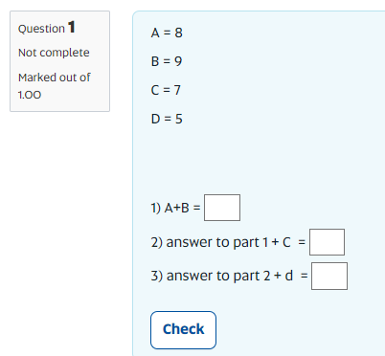

1. To add a Formulas question, go to the left-hand navigation and select *administration -> course administration -> question bank*. Then select *create a new question* and then *Formulas*.
2. Give your question a name (perhaps use your initials in the title to make it easier to find this question again should you need to edit it).
3. In the *random variables* box, you will enter a letter or word which you will then associate with a range of values, for this question, enter:  
    A = {1:11:1};

B = {1:11:1};

C = {1:11:1};

D = {1:11:1};

to deconstruct the first line, it is assigning the letter A to be a random number between 1-11 (but not including 11), then it is states that the random number should be to generated with an interval of 1 (i.e. 1,2,3 etc.).

1. In the *global variables* box, you will enter any formulas that Moodle should use to manipulate the random variables you entered in the previous box, for this question, enter:  
    SolA=A+B;

SolB=SolA+C;

SolC=SolB+D;

the first line of this formula is telling Moodle to firstly add A and B and assign it to a new variable SolA.

1. In the *question text box* enter the following to display the variables and their values to students.  
    A = {A}

B = {B}

C = {C}

D = {D}

1. Under *Part 1* click *show more* and in the *grading variables* box enter:  
    a1=_0==SolA;

a2=_1==SolB;

a3=_2==SolC;

a4=_1/(_0+C) <= 1.01 && _1/(_0+C) >= 0.99;

a5=_2/(_1+D) <= 1.01 && _2/(_1+D) >= 0.99;  
the first three lines tell Moodle to assign a value of 1 or 0 to the variable a1 depending on whether the students’ answer (_0) is the same as the expected answer (SolA) – this value of 1 or 0 is then used in step 8 of these instructions. The final two lines tell Moodle to assign a value of 1 or 0 to the variable a4 depending on whether the students’ answer is correct in relation to their answer to part 1 of the question.

1. In the *answer* box, enter:  
    [SolA,SolB,SolC]

this tells Moodle the expected answers for each part of the question (as defined in the global variables box earlier)

1. In the *grading criterion* box enter:

max((a1*0.333333+a2*0.333333+a3*0.333333),(0.2*a4+0.2*a5))

this formula calculates the students’ marks for the question, the first brackets state that if the student enters the expected answers they will get a third of the marks for each correct answer. The second set of brackets gives students 0.2 marks if their first answer is incorrect but they have used it to calculate the correct answer for the second and third parts of the question.

**Question 4 – algebraic questions**

We have included this question for those that like a challenge, but be warned, this is very complicated! Our instructions are intentionally sparse (in part, because we made this question a while ago and can’t entirely remember what we did/why…)

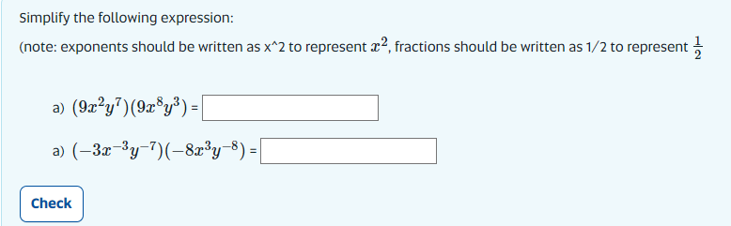

1. Random variables:

a = {1:10:1};

b = {1:10:1};

c = {1:10:1};

d = {1:10:1};

e = {1:10:1};

f = {1:10:1};

g = {-9:0,1:10:1};

h = {-9:0:1};

i = {-9:0,1:10:1};

j = {-9:0:1};

k = {-9:0,1:10:1};

l = {-9:0:1};

1. Global variables:  
   q1 = "$$(";

q2 = str(a);

q3 = "x^{";

q4 = str(b);

q5 = "}y^{";

q6 = str(c);

q7 = "})(";

q8 = str(d);

q9 = "x^{";

q10 =str(e);

q11 = "}y^{";

q12 = str(f);

q13 = "})$$";

questiona= join("",q1,q2,q3,q4,q5,q6,q7,q8,q9,q10,q11,q12,q13);

calca = a*d;

calcb=b+e;

calcc=c+f;

ansa="calca x^calcb y^calcc";

q14 = "$$(";

q15 = str(g);

q16 = "x^{";

q17 = str(h);

q18 = "}y^{";

q19 = str(i);

q20 = "})(";

q21 = str(j);

q22 = "x^{";

q23 =str(k);

q24 = "}y^{";

q25 = str(l);

q26 = "})$$";

questionb= join("",q14,q15,q16,q17,q18,q19,q20,q21,q22,q23,q24,q25,q26);

calcd = g*j;

calce=h+k;

calcf=i+l;

ansb="calcd x^calce y^calcf";

1. Question text:  
   Simplify the following expression:

(note: exponents should be written as x^2 to represent \(x^2\), fractions should be written as 1/2 to represent \(\frac{1}{2}\)

{#1}

{#2}

1. Part 1 local variables:  
   x = {10:100:1e-9};

y = {10:100:1e-9};

calca = a*d;

calcb=b+e;

calcc=c+f;

ans1 = "$$(";

ans2 = str(calca);

ans3 = "x^{";

ans4 = str(calcb);

ans5 = "}y^{";

ans6 = str(calcc);

ans7 = "})$$";

solutiona = join("",ans1,ans2,ans3,ans4,ans5,ans6,ans7);

1. Part 1 general feedback:  
   {solutiona}
2. Part 1 answer type:  
   algebraic formula
3. Part 1 answer:  
   ansa
4. Part 1 placeholder name:  
   #1
5. Part 1 part’s text:

a) {questiona} = {_0}

1. Part 2 local variables:  
   x = {10:100:1e-9};

y = {10:100:1e-9};

calcd = g*j;

calce=h+k;

calcf=i+l;

ans8 = "$$(";

ans9 = str(calcd);

ans10 = "x^{";

ans11 = str(calce);

ans12 = "}y^{";

ans13 = str(calcf);

ans14 = "})$$";

solutionb = join("",ans8,ans9,ans10,ans11,ans12,ans13,ans14);

1. Part 2 general feedback:  
   {solutionb}
2. Part 2 answer type:  
   algebraic formula
3. Part 2 answer:  
   ansb
4. Part 2 placeholder name:  
   #2
5. Part 2 part’s text:

b) {questionb} = {_0}

**Further resources:**

* Moodle Formulas help resources - <https://moodleformulas.org/>
* OED Consults (Richard, Anne, or James) - <https://lo.unisa.edu.au/course/view.php?id=20251>

<https://www.youtube.com/watch?v=qxjTFaRYaCk>

<https://www.youtube.com/watch?v=S2WE6KtM1cs>

<https://www.youtube.com/watch?v=FDUcGQ_dsJo>

<https://www.youtube.com/watch?v=qxjTFaRYaCk>